Darla Newland
Think Sheets
EDIT 5342

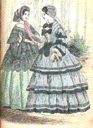

Women’s Researcher

You are the women’s researcher and reporter for the “Gilded Age” documentary.
Through Internet research, you will word process an individual report over the women of this time period of the late 1800’s. Some interesting information could be:

What was life like for women during the gilded age?

Who were some famous women of this time and what made them famous?

What type of jobs did they hold, and how were the working conditions of the women?

What are women’s movements and what impact did they have on society then and now?

Other research questions…

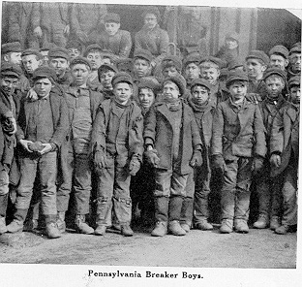
Coal Mining Industry Researcher

You are the Industry researcher and reporter for the “Gilded Age” documentary.
Through Internet research, you will word process an individual report over the coal mining industry of the late 1800’s. Some interesting information could be:

What was the life of a coal miner like?

Who worked the mines?

How safe were the mines?

What economic value did the mines bring?

How are coal miners and mine conditions today, and what made them different?

Other research questions…
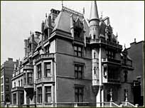

Big Business and The Rich Researcher

You are Big Business and The Rich researcher and reporter for the “Gilded Age” documentary. Through Internet research, you will word process an individual report over the rich and big businesses of this time period of the late 1800’s. Some interesting information could be:

Who were the rich, and what business did they own

What affect did the big business have on home businesses and the craftsman?

What work was held within the business (assembly lines, etc.), and who were the workers?

What were the wages, work day hours, and safety of the laborers of big business?

What movements was the result of big business?

What are monopolies?

Other interesting research…
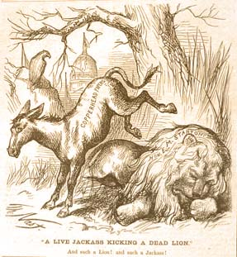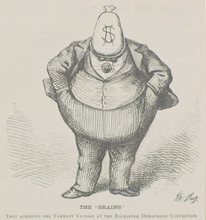
Cartoon Researcher

You are the cartoon’s researcher and reporter for the “Gilded Age” documentary.
Through Internet research, you will word process an individual report over the cartoons of this time period of the late 1800’s. Some interesting information could be:

Who were famous cartoonists?

What were the cartoons about?

Why did they draw these cartoons?

Give examples of cartoons and what they meant.

Do we still have political cartoons?

Other interesting research…

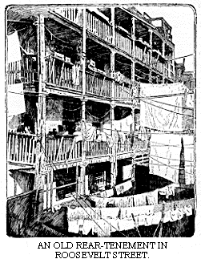

How the Other Half Lives by Jacob Riis, Chapter Researcher:

You will read and research Chapter________ of this literature describing

the lifestyle of the people in the late 1800’s. Things to look for:

What is this chapter about?

What is important for us to know about this chapter?

What influence did it have on society?

What were the physical, emotional, and mental conditions of those described?

What movements were brought about as a result of the living conditions?

What effect did it have on today’s society?

Other interesting information found in your chapter.

